### Introduction

This report provides data and analysis of the pay differentials between the Trust’s male and female employees to inform our strategic work in this area and to fulfil the Trust’s statutory duties in accordance with The Equality Act 2010 (Specific Duties and Public Authorities) Regulations 2017.

Whilst the gender pay gap is undoubtedly a challenge within the education sector given the predominantly female workforce, The Elliot Foundation Academies Trust is committed to developing, maintaining and supporting a culture of equality and diversity across all aspects of our work, including pay, benefits and professional development opportunities. This requires continued effort to understand our gender pay gap and work to address the areas of impact.

The Trust is confident the gender pay gap does not reflect men being paid more than women to perform the same job roles. However, the dominance of a female workforce overall and in particular, the imbalance of the proportion of females employed in less senior roles within our staffing structures is a significant contributing factor. The lowest paid positions with the Trust are cleaners, caterers and less experienced Teaching Assistants/Classroom Assistants and these posts are predominantly fulfilled by females. These factors are consistent with the majority of the education sector, particularly primary schools, and arguably reflect societal norms and bias.

Despite this, the Trust is committed to continuing to explore ways in which we can examine and tackle the gender pay gap:

* we operate clear governance and job evaluation processes which assess the salary command of the post and is not specific to the occupant
* we adopt both School Teachers’ Pay and Conditions Document recommendations and the Burgundy Book conditions for teaching staff and the Green Book conditions for support staff
* we apply equitable and consistent automatic pay progression across both support and teaching roles, with a central Trust governance process in place to review exceptional pay recommendations
* we have continued to develop and promote the flexibilities we are able to offer employees, including establishing our first ever co-headship of one of our schools which is proving extremely successful.
* we have reviewed the Trust’s executive pay scales to achieve improved equity across the group
* we are currently engaging in a variety of staff voice activities intended to develop our understanding of what more we can do to retain and develop employees, including females in leadership roles
* we continue to promote the Trust’s Equality and Diversity Policy, Family Friendly Policy and Flexible Working Policy. These are intended to support a fair and equitable culture and enable employees to develop their careers whilst managing other commitments
* we are developing an expanding core Continuous Professional Development offering available to both teaching and support staff and strengthening the communities and professional networks available to staff across the organisation

### 

### Employee Headcount Gender Ratio*

| **Gender** | **Headcount** | **Percentage** |
| --- | --- | --- |
| **Male** | 183 | 8.72% |
| **Female** | 1915 | 91.28% |
| **Total** | 2098 | 100% |

### *\* Based on actual employee headcount discounting additional multiple contracts*

### ChartGender Pay Differentials

**Gender Ratio Quartile Analysis**

| **Hourly Rate of Pay Quartiles** | | | | | | | | |
| --- | --- | --- | --- | --- | --- | --- | --- | --- |
| **Gender** | **Lower** | | **Lower Middle** | | **Upper Middle** | | **Upper** | |
| **Headcount** | **%** | **Headcount** | **%** | **Headcount** | **%** | **Headcount** | **%** |
| **Male** | **19** | **3.62** | **25** | **4.77** | **58** | **11.05** | **81** | **11.05** |
| **Female** | **506** | **96.38** | **499** | **95.23** | **467** | **88.95** | **443** | **88.95** |
| **Total** | **525** |  | **524** |  | **525** |  | **524** |  |

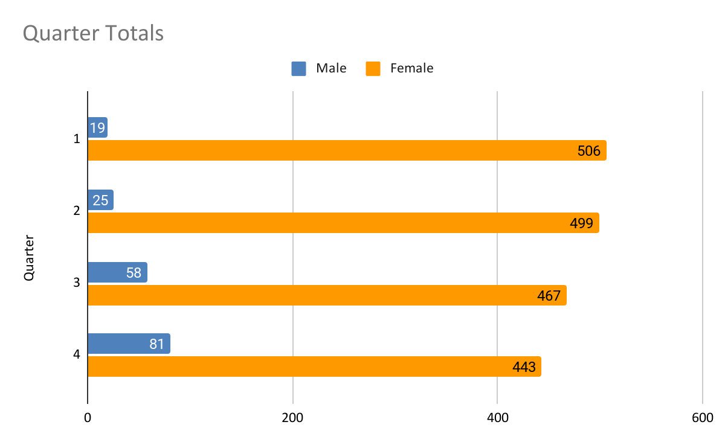

**Pay Rates**

| **Gender** | **Median Gender Hourly Rate (£) \*** | **Mean Gender Hourly Rate (£)\*\*** |
| --- | --- | --- |
| **Male** | **£19.92** | **£22.72** |
| **Female** | **£13.70** | **£16.93** |

***\* median = the value separating the higher half from the lower half of a data sample***

***\*\*mean = calculated by adding all data points and dividing by the number of data points***

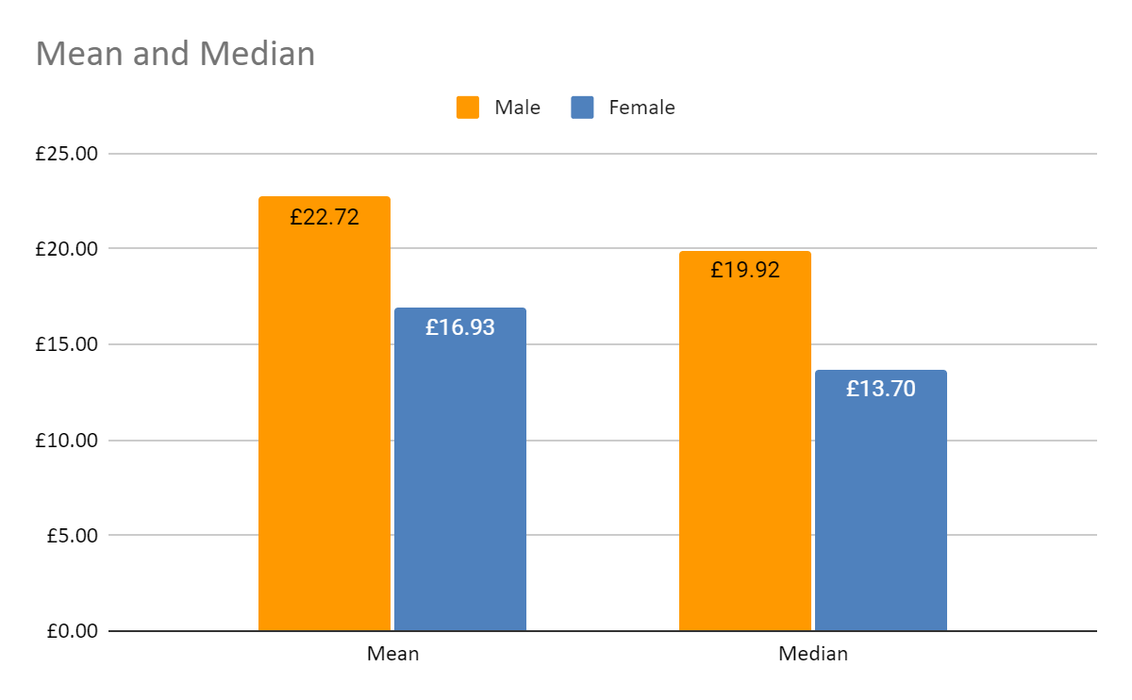

**Gender Pay Gap\***

|  | **2018** | **2019** | **2020** | **2021** | **2022** | **2023** |
| --- | --- | --- | --- | --- | --- | --- |
| **Median Gender Hourly Pay Gap** | **27.2** | **28.3** | **32.88** | **24.28** | **30.25** | **31.23** |
| **Mean Gender Hourly Pay Gap** | **23.9** | **24.0** | **30.38** | **24.37** | **25.38** | **25.46** |

***\* see notes below re year over year comparison***

**Gender Bonus Pay Ratios**

No staff were in receipt of a bonus

**Notes**

* The Trust’s headcount has increased due to an additional school joining the Trust since the previous data capture date
* The significant majority of the Trust’s workforce continues to be comprised of female employees with the headcount gender ratio remaining largely unchanged on the previous 3 years at circa 90%
* The gender split between the quartiles has altered slightly since the previous report, with small increases in the numbers of females in the upper middle and upper pay quartiles for the second consecutive year